Information for Swimmers, Coaches & Spectators attending the Rotherham Metro Open Meet 18th September 2021
Swimmers & Coaches:
Please access the competition pool via the upper doors leading onto the balcony, team seating is situated in the ‘spectator’ seating on the left-hand side as you enter the competition pool (side opposite the Omega suite). Seating will not be allocated so we ask teams to assign their own areas maintaining appropriate distancing.
A one-way system is in place for swimmers and they should use the stairways to gain access to and from the poll deck as indicated below. The wearing of facemasks is not a requirement but is recommended.
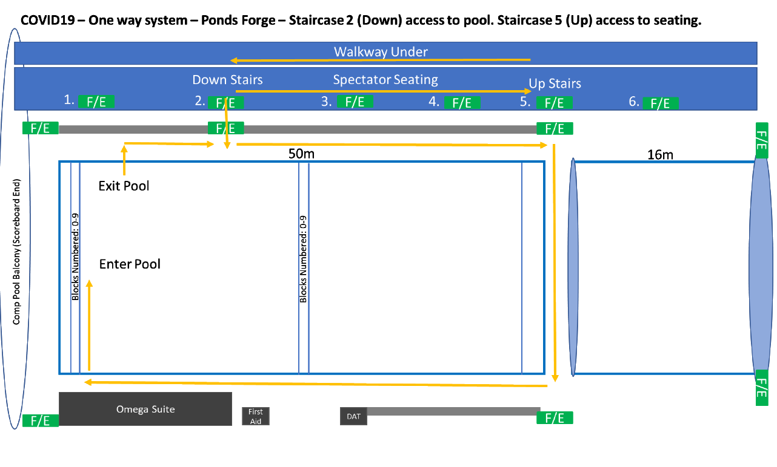
Spectators:
Spectators are permitted at the gala, but seating is restricted to the seating on the right-hand side of the competition pool as you enter (the Omega side). Please maintain appropriate distancing. The wearing of facemasks is not a requirement but is recommended.
Parking info: Ponds Forge recommend parking just across the road at Castle Gate Q-Park, Broad Street where discounted prices will be honoured for anybody attending an event at Ponds Forge. Scan your Q-Park voucher at the main reception desk to receive the discounted parking. Parking is £1 per hour up to a maximum of £6.70, which for a full day is more cost effective than Ponds Forge car park (terms and conditions apply).
You are also welcome to use the Ponds Forge car park where parking costs are £2 for up to 2 hours, £4 for up to 4 hours, £5.50 for up to 6 hours and £10 for up to 12 hours. Please note with every car park ticket purchase a £2 voucher will be issued to the customer which can be redeemed on leisure activities or in the onsite café.

