

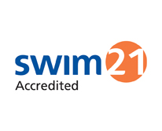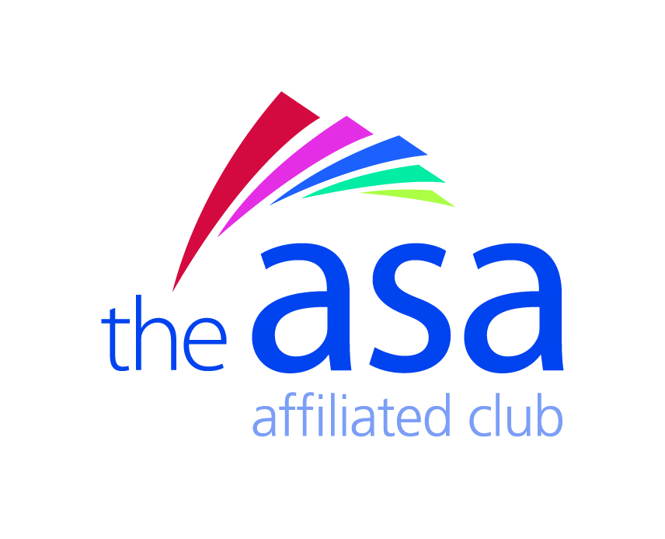

**Code of conduct for Rotherham Metro Swimmers**

* Arrive for training and competition on time, prepared and with the correct kit as requested by the Coach. Do not enter the water until the coach has instructed you to do so.
* Inform the Coach before the start of training if you have any illness / injury which may affect your training.
* Look at and listen to the Coach when they are speaking and follow the instructions given in training and at competition.
* Behave appropriately in the water. Do not sit or pull on lane ropes or disrupt other swimmers.
* Respect fellow swimmers at all times. Bullying in any form (whether that be Emotional (which includes Excluding), Physical, Racist, Sexual, Homophobic and Verbal (including written telephonic and electronic communications (including (without limitation) on Facebook, Twitter or other “Social Media”), but not limited to these), will not be tolerated.
* Behave sensibly in the changing rooms.
* Notify the team selectors / Coach as soon as possible if you cannot attend a gala for which you have been selected. Be proud to wear your team kit.
* If swimming for your club, stay with your team on poolside. Inform the coach or team manager where you are going if you leave the poolside.
* Do and say nothing that will bring the Club into disrepute.
* Personal conduct must at all times be of a high standard and reflect favourably on the sport and the Club. Bad language in public or relevant group situations is not acceptable.
* Speak to the Coach to get feedback after every race.
* Enjoy your swimming and be a good sport whether you win or lose.
* Performance enhancing drugs and substances are strictly forbidden. Swimmers are expected to be aware of the current list of banned substances and particular care must be exercised if anyone is on medication prior to or during a competition.
* Illegal drugs and substances: The use of these, even though they may not appear on the official banned list in respect of performance enhancing drugs, is nonetheless prohibited.